1. Summer Palette - <https://coolors.co/ea9898-ffdeaa-816d7d-afb1db-d4cde6>

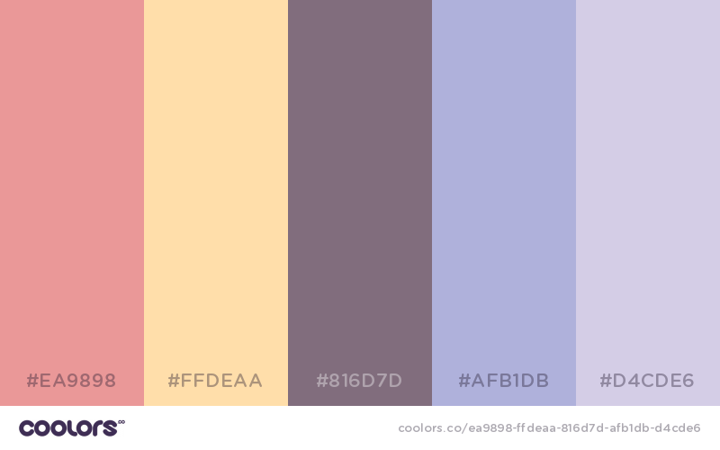

2. Temple Football Color Scheme - <https://coolors.co/4c4d58-511b2a-99212b-dce4e6-ffbe63>

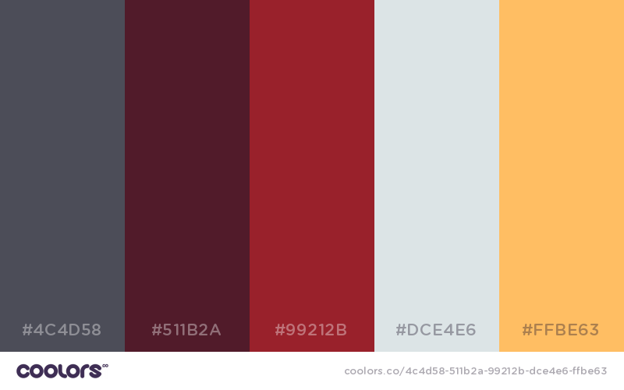

3. SMC+ Website Color Scheme – <https://coolors.co/987d98-bcabac-84b6a7-acc2bc-ae893f>

